

**ECEN 5053-003 Homework Assignment**

Course Name: Embedding Sensors and Actuators

Corresponding Module: C1M4

Week Number: 4

Module Name: Amplifiers and Sensor Noise

Submitted by Poorn Mehta

Note: References are from Lecture Slides provided by Prof. Mendelson, exceptions are noted.

Homework is worth 100 points for Parts A and B combined.

Part 1: Each question is worth 5 points.

1. An inverting op amp has Vin = .056 volts, R2 = 1000 ohms and R1 = 50 ohms. What is Vout in volts?

Answer: **-1.12V**

Vo / Vin = -R2 / R1 for inverting op amp. Thus, Vo = Vin * (-R2 / R1)

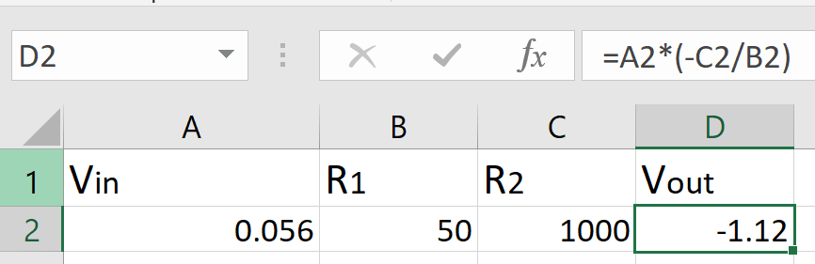

1. A non-inverting op amp has Vout = 2.55 volts, R2 = 2000 ohms and R1 = 100 ohms. What is Vin in volts?

Answer: **0.121V**

For non-inverting op amp, Vo / Vin = 1 + (R2 / R1). Therefore,

Vin = Vo / (1 + (R2 / R1)).

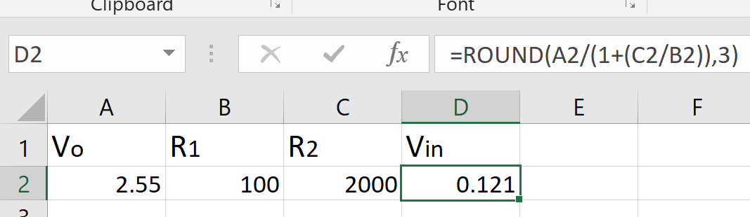

1. An A summing amplifier with N = 3 has RF = 2500 ohms, V1 = 0.154 volts, R1 = 200 ohms; V2 = .059 volts and R2 = 100 ohms; V3 = .104 volts and R3 = 500 ohms. What is Vout involts?

Answer: **-3.92V**

For summing amplifier Vo = -RF * (V1/R1 + V2/R2 + V3/R3)

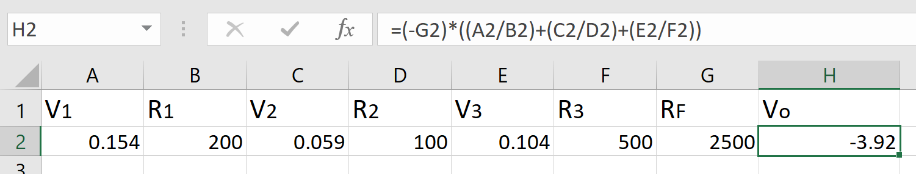

D. A differential amplifier has R4 = 5000 ohms, V1 = 0.294 volts, R3 = 500 ohms and V2 = -.094 volts. What is Vout in volts?

Answer: **3.88V**

For differential amplifier, Vo / (V1 - V2) = R4 / R3. Thus,

Vo = (V1 - V2) * (R4 / R3)

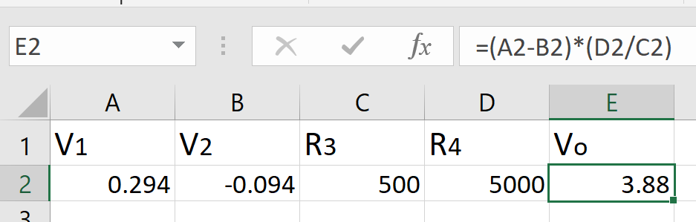

1. You are using an instrumentation amplifier to measure the difference between two very small sensor signals. V1 = 41.27 mV, V2 = 38.43 mV, R4 = 5000 ohms, R3 = 100 ohms, R2 = 3000 ohms and R1 = 500 ohms. What is Vout in milli-volts?

Answer: **-1846mV**

For instrumentation amplifier, Vo = (V2 - V1) * (R4 / R3) * ((R1 + (2*R2)) / R1)

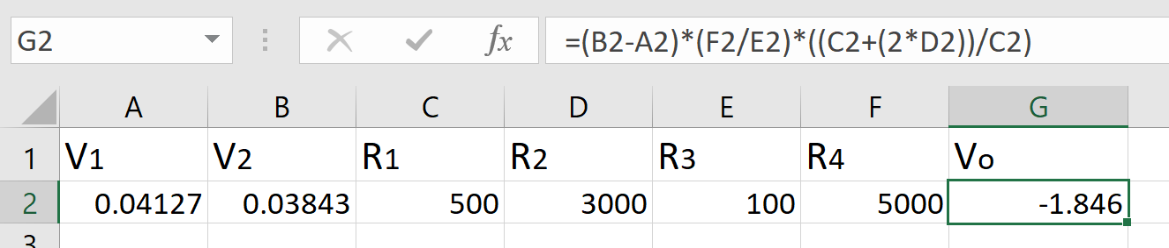

1. Suppose you have an amplifier with an input offset voltage of .08 mV as measured at 25 °C and a thermal drift of the input offset voltage of 0.4 μV/ºC away from this temperature. Your amplifier has a gain of 90, and the circuit in which it is installed in operating an elevated temperature of 40°C. How much is the output in mV offset by your input offset voltage?

Answer: **7.74mV**

Input offset voltage is 0.08mV at 25°C, with thermal drift of 0.4µV/°C – and the amplifier is operating at 40°C. Therefore, new input offset voltage = 80µV + ((40°C - 25°C) * 0.4µV/°C). Since the gain is gain is 90, the output voltage = Input offset voltage at 40°C * 90.

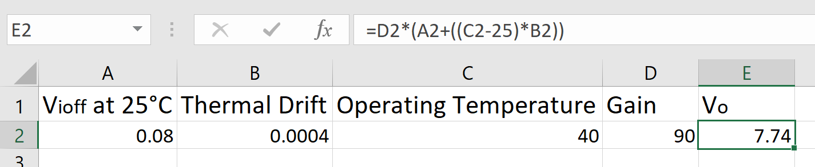

1. Suppose an op amp with a slew rate of 0.24 V/µs is amplifying the signal 6 sin (20,000,000t) mV. Will the amplified signal be distorted? Why or why not?

Answer: **No. Min slew rate is 120KV/s, op amp has 240KV/s**

An op amp needs a minimum slew rate of 2πfVo to amplify an input signal Vo sin (2πft) without distortion. Therefore, 2πf = 2*107, and Vo = 6*10-3V. Thus, minimum required slew rate = 120*103 = 120KV/s. Now the given op amp has the slew rate of 0.24V/µs. Multiplying it with 106 to have the slew rate per second, we have 240KV/s. As this is twice the minimum for the given signal, the amplified signal will not be distorted.

1. The Johnson-Nyquist noise in a resistor in a circuit of 2 Mhz bandwidth is 60 nV / √hz. What is the magnitude of the noise in the resistor in μV?

Answer: **84.852µV**

The Johnson-Nyquist noise in the given resistor is 60nV/√hz. To find the noise at given frequency, the noise should be multiplied by the square root of given bandwidth [**[1 – last slide]**](https://www.physics.queensu.ca/~phys352/lect04.pdf). So magnitude of noise = 60nV * √(2*106) = 60 * 1.4142 * 103 = 84.852µV.

1. What is the signal to quantization noise ratio (SNR) of a sine wave in a 16 bit ADC?

Answer: **98.097dB**

The SNR of a sine wave in an ADC is given by the following expression: SNR = 6.021 * Q + 1.761dB, where Q is the number of bits in the ADC. Therefore, SNR = 98.097dB.

1. Your raw thermocouple sensor signal is 31 mV, and you are using an instrumentation amplifier to process it. The amplifier has a CMRR of 60dB and a differential mode gain of 110. If the RF noise on the leads from the thermocouple sensor to the data logger is 34 mV, what will be the percentage of noise on the amplified signal?

Answer: **0.109557%**

The CMRR = 20*log10(Adiff / Acmrr). Given value for CMRR is 60dB, and differential mode gain is 110. Therefore,

60 = 20* log10(110 / Acmrr). Taking anti log on both sides,

103 = 110 / Acmrr . Thus,

Acmrr = 110 / 1000 = 0.11. This will give out Voltage due to common mode rejection Vcm = 0.11 * 0.034 = 3.74mV. Vo without Vcm would be

0.031 * 110 = 3.41V. The total value of the output = 3.41374V, out of which only 3.74mV is due to noise.

Percentage of noise = (100 / 3.41374V) * 3.74mV = 0.109557%.

Part 2: Each question is worth 10 points.

1. How does Analog Devices Inc. measure the input offset voltage on their amplifiers?

Answer:

Analog Devices Inc. uses an auxiliary amplifier, along with Device Under Test, as an integrator. It is configured to be open-loop (full gain) at dc, but its input resistor and feedback capacitor limit its bandwidth to a few Hz. This means that the dc voltage at the output of the DUT is amplified by the full gain of the auxiliary amplifier and applied, via a 1000:1 attenuator, to the noninverting input of the DUT. Thus, the voltage on the test point, TP1, is 1000 times the input offset voltage at the input terminals of DUT. This will be tens of mV or more and, so, quite easy to measure [**[2]**](http://www.analog.com/en/analog-dialogue/articles/simple-op-amp-measurements.html) . The circuit is shown in the figure below:

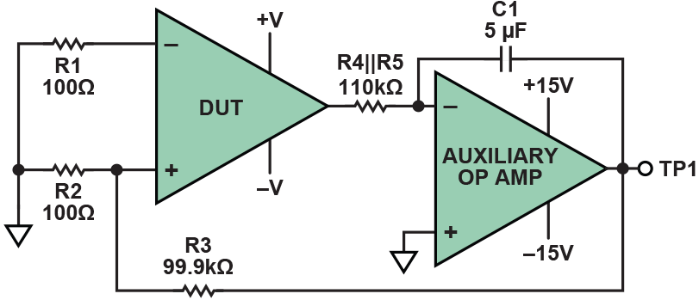

1. How does Analog Devices Inc. measure the common mode rejection ratio on their amplifiers?

Answer:

Following is the circuit diagram and description of the method that is being used by Analog Devices Inc. to measure the CMRR on their amplifiers [**[3]**](http://www.analog.com/en/analog-dialogue/articles/simple-op-amp-measurements.html) .

The common-mode rejection ratio (CMRR) of an op amp is the ratio of apparent change of offset resulting from a change of common-mode voltage to the applied change of common-mode voltage. It is often of the order of 80 dB to 120 dB at dc, but lower at higher frequencies.

The following test circuit is ideally suited to measuring CMRR. The common-mode voltage is not applied to the DUT input terminals, where low-level effects would be likely to disrupt the measurement, but the power-supply voltages are altered (in the same—i.e., common—direction, relative to the input), while the remainder of the circuit is left undisturbed.

In the circuit, the offset is measured at TP1 with supplies of ±V (in the example, +2.5 V and –2.5 V) and again with both supplies moved up by +1 V to +3.5 V and –1.5 V). The change of offset corresponds to a change of common mode of 1 V, so the dc CMRR is the ratio of the offset change and 1 V.

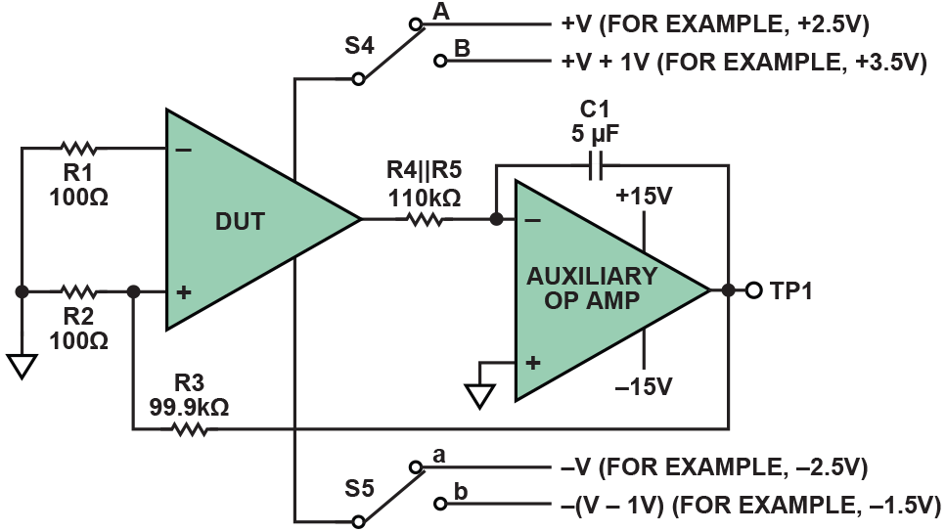

1. Study table 5 (Pin Configuration and Function and Function Descriptions from the spec sheet for the Analog Devices Inc. AD8422 with this device operating at a nominal gain of 1000.

What value of gain resistor would you place across the Rg pins to use this nominal gain? Select an appropriate resistor from the Digikey web site.

Now study figures 22 and 23 from the spec sheet for the AD8422, with this device operating at a nominal gain of 1000 at 10HZ.

Suppose your raw sensor signal is a sin wave with magnitude 4.6 mV and frequency 20,000 hz.  and you are using the AD8422 amplifier to process it. The RF noise on the leads from the sensor to the data logger is 23 mV, what will be the percentage of noise on the amplified signal (i.e. the SNR)?

Answer: **19.82Ω & 0.002811%**

According to the datasheet, Gain = 1 + (19.8kΩ / RG) [**[4 – page 9]**](http://www.analog.com/media/en/technical-documentation/data-sheets/AD8422.pdf) .

Thus, RG = 19.8kΩ / (Gain – 1). For Gain = 1000,

RG = 19.8kΩ / 999 ≈ 19.82Ω. The resistor with closest value is the one with 19.80Ω, on digikey [**[5]**](https://www.digikey.com/products/en/resistors/chip-resistor-surface-mount/52?k=resistor&k=&pkeyword=resistor&pv2085=u19.8+Ohms&sf=0&FV=ffe00034&quantity=&ColumnSort=0&page=1&pageSize=25).

First, CMRR and Gain at 20kHz should be found out using the graph given in the datasheet [**[6 – page 13]**](http://www.analog.com/media/en/technical-documentation/data-sheets/AD8422.pdf). This will result in approximate value of 105dB for CMRR and 55dB for gain. Converting gain into absolute value,

55 = 20*log10(Gain). So Gain = 102.75 ≈ 562. Using the CMRR equation, CMRR = 20*log10(Aol / Acmrr),

105 = 20* log10(562 / Acmrr). Taking anti log on both sides,

105.25 = 562 / Acmrr . Thus,

Acmrr = 562 / 177828 = 0.00316. This will give out Voltage due to common mode rejection Vcm = 0.00316* 0.023 = 72.68µV. Vo without Vcm would be

0.0046 * 562 = 2.585V. So the percentage of error would be

(Vcm / (Vo + Vcm)) * 100 %

= (0.007268 / 2.58507268) % = 0.002811%

1. How does Sensors Online magazine recommend that you perform digital noise measurements on a MEMS accelerometer, and minimize them accordingly?

Answer:

According to the Sensors Online magazine [**[7]**](https://www.sensorsmag.com/embedded/noise-measurement) , **first the test environment is setup properly to protect it from various external noise sources**. For this, the accelerometer is mounted on a large mass on an isolation table that floats on compressed air. The isolation table is placed in a room on the ground floor to minimize building vibrations. The room is temperature-controlled and quiet, with no heavy machinery operating nearby. For electrical isolation, the sensor under test is typically powered using a battery rather than a DC power supply because the battery provides a clean DC voltage without coupling any 60 Hz noise into the system.

**For digital noise measurement, special attention is paid to the Aliasing/Nyquist Theorem. Therefore, sensors to be tested should be bandwidth-limited accordingly.** The required sampling frequency in accordance with the Nyquist Theorem is the Nyquist frequency (fN) given by fN = 2 * f­-3dB , where f-3dB is the cutoff frequency of low pass filter. Also, **to measure the input-referred noise, the input to the ADC needs to be heavily decoupled by setting the low-pass filter frequency to 50 Hz or lower and then a large number of samples can be collected and plotted as a histogram.**

**The input-inferred noise could be reduced by placing a higher-order filter on the outputs or by reducing the bandwidth of the filter. Another technique that can be used to reduce noise is over-sampling and averaging**. Oversampling involves sampling a signal using a sampling frequency that is significantly higher than that of the Nyquist frequency. This way, noise is greatly reduced.

1. What is an operational amplifier?

Answer:

An Operational Amplifier, or op-amp for short, is fundamentally a voltage amplifying device designed to be used with external feedback components such as resistors and capacitors between its output and input terminals. These feedback components determine the resulting function or “operation” of the amplifier and by virtue of the different feedback configurations whether resistive, capacitive or both, the amplifier can perform a variety of different operations, giving rise to its name of “Operational Amplifier” [**[8]**](https://www.electronics-tutorials.ws/opamp/opamp_1.html) .

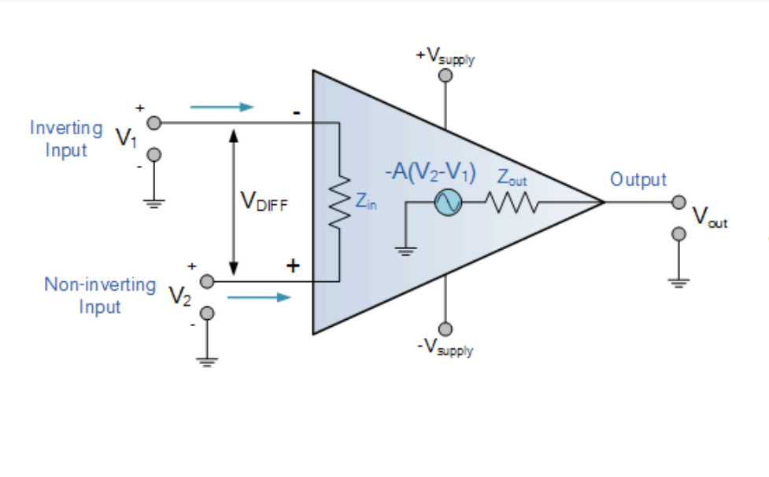

An Operational Amplifier is basically a three-terminal device which consists of two high impedance inputs. One of the inputs is called the Inverting Input, marked with a negative or “minus” sign, ( – ). The other input is called the Non-inverting Input, marked with a positive or “plus” sign ( + ).

A third terminal represents the operational amplifiers output port which can both sink and source either a voltage or a current. In a linear operational amplifier, the output signal is the amplification factor, known as the amplifiers gain ( A ) multiplied by the value of the input signal and depending on the nature of these input and output signals, there can be four different classifications of operational amplifier gain.

Voltage – Voltage “in” and Voltage “out”

Current – Current “in” and Current “out”

Transconductance – Voltage “in” and Current “out”

Transresistance – Current “in” and Voltage “out”

Op Amps have many characteristics and parameters, covering all of them in detail would require a multitude of pages. Therefore, I will limit my answer and post some URLs which are quite good for learning Op Amp [**[9]**](https://www.electronics-tutorials.ws/opamp/opamp_1.html)[**[10]**](http://www.analog.com/media/en/training-seminars/design-handbooks/Op-Amp-Applications/Section1.pdf)[**[11]**](https://www.radio-electronics.com/info/circuits/opamp_basics/operational-amplifier-basics-tutorial.php)[**[12]**](https://electronicsforu.com/resources/learn-electronics/op-amp-basics-operational-amplifier) .